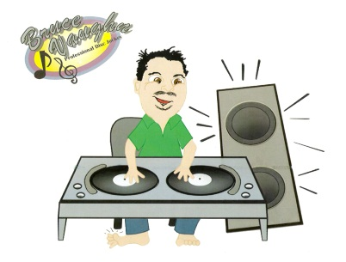 Balance Due --
Contract time –

Up-Lighting --___________
Date of Wedding --
Bride’s Name--
Bride’s Phone# --
Groom’s Name –
Groom’s Phone # --
Ceremony Location & Time --
Reception Location & Time –

Cocktail Hour Start Time --
Entrance Time –
Song –
Toast Start Time –
Toast Given By –
Prayer Given By --
Dinner Music Time –

Cake Cutting Time—
Song –

First Dance of Bride & Groom Time—
Song –
Father / Daughter Dance Time —
Song –
Groom / Mother Dance Time –
Song –
Money Dance/ Dash for cash Time –
Song –

Anniversary Dance Time --
Song –
Bouquet & Garter Time –
Bouquet Toss --
Garter Removal –
Garter Toss --

Novelty Songs to Play -- Cha Cha Slide, Cupid Shuffle,Wobble, The Git Up, Whip Nae Nae , Cleveland Shuffle, Electric Slide, Macarena, Tootsie Roll, Dougie,Soldier Boy, Ymca , In The Navy , Chicken Dance, Hokey Pokey

Wedding Party
Bride & Groom –
Bride’s Parents --

Groom’s Parents –

Maid / Matron of Honor --
Best Man –
Bridesmaids Groomsman

Bride’s Grandparents –
Groom’s Grandparents –
Junior Bride/ Junior Groom –

Flower Girl / Ring Bearer –

Other Attendants –

Request

Ceremony
Prelude Start time—
Prelude Music –

Bridal Party Processional Time—
Bridal Party Song –

Bridal Processional song—
Sand / Candle Ceremony –
Exit Song--

